A Thing I Hate
Name: Zhenyu Song
Email: zhenyus4@uci.edu
Course: SWE 263P
Date: April 10, 2026
Assignment: A Thing I Hate: The UCI Campus Rec App
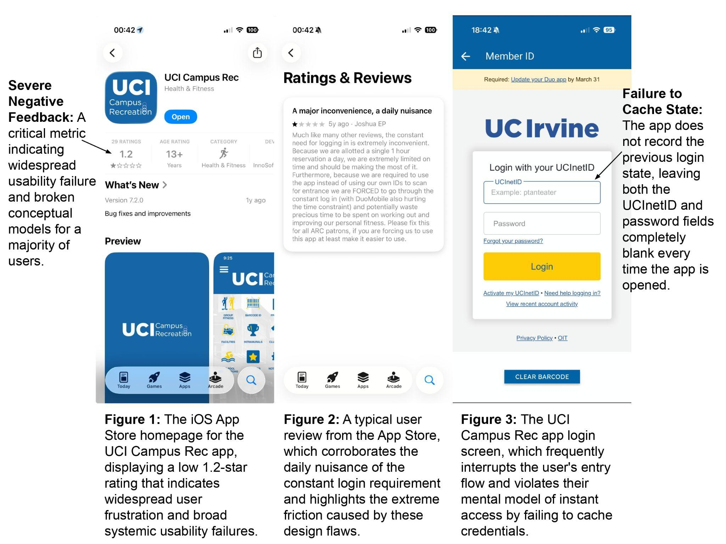
As a student at UCI, one of the most frustrating interfaces I interact with daily is the UCI Campus Rec Mobile Application. To enter the Anteater Recreation Center (ARC), students must scan a barcode at the front turnstiles. While physical ID cards exist, the ARC heavily promotes the app as the primary and most convenient method for accessing this required digital barcode. The intended user flow is supposed to be seamless: walk up to the entrance, open the app, tap the "Member ID" icon, and scan the barcode to enter.
However, the actual experience rarely matches this intended flow. This is a widespread usability failure reflected in the app's exceptionally low App Store rating (As seen in Figure 1). Almost every time I arrive at the gym, the app has failed to cache my login status. Instead of displaying my barcode, it forces me to log in again from scratch (As seen in Figure 3). This constant friction is a daily nuisance corroborated by numerous other user reviews (As seen in Figure 2). To make matters worse, the cellular network just outside the ARC is notoriously weak. After entering my credentials, the app frequently hangs on a loading screen. I often end up standing awkwardly in the busy entrance line, waiting for my barcode to finally appear so I do not block other students.
We can understand why this app is so frustrating by looking at Don Norman’s The Design of Everyday Things. The core problem is a mismatch between the user's mental model and the system's conceptual model. My mental model of an ID card, basically shaped by physical wallet cards, is that it's a static object, always ready to show. But the system's conceptual model is completely different: the app treats the ID as a cloud-dependent portal that needs active network authentication to verify your membership each time. Because the designers never really bridged this gap, the resulting system image is a slow, multi-step process that feels nothing like how a normal ID is supposed to work.
On top of that, the app gives you almost no useful feedback when the network is bad. Norman's point is that feedback should be immediate and clear, and this app fails that pretty badly. When the connection at the ARC is weak, it just sits there on a loading screen. You have no idea if it's still authenticating, waiting for a signal, or already timed out. That's a textbook example of “Gulf of Evaluation”: with no clear system status, I'm just standing there guessing whether to wait or restart the whole thing.
In conclusion, the UCI Campus Rec app has two pretty fixable problems. It doesn't match the mental model users naturally bring to it, and it leaves you in the dark whenever something goes wrong. Caching the login and letting the barcode work offline can help a lot. It's not a hard fix, which honestly makes it more frustrating that it hasn't been done.

